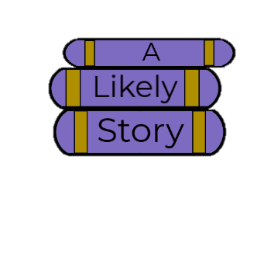



Account

Books | E-books | Toys & Games | Movies & Music | Gifts | Sales | Locations | About

Body: Page hero, new/sales/ads/exclusives, < ||| >, gift guide link, categories, boxed sets, video

1. Today's Top Sellers
2. What Every Kid Wants: Get the Top Toys Before They're Gone!
3. New Releases
4. Celebrating 20 Years of Harry Potter Magic!
5. Our Favorite Funko POPs!
6. Coming Soon: Pre-Order the Next Bestseller Today!

Sign up for our newsletter! Join our club and get exclusive deals! F T I L P

|_______________________|O\ |__________________________________|O\

 Home | Books | E-books | Toys & Games | Movies & Music | Gifts | Sales | Locations | About

Copyright 2018